Project Name | Securing IT Infrastructure of Legacy Banking Systems from Quantum Attacks using Hybrid Post Quantum TLS  Implementation
Background Information | Financial institutions rely extensively on public-key cryptography algorithms such as RSA and Elliptic Curve Cryptography (ECC) to secure key exchange,  digital signatures, TLS, VPNs, email, and PKI. Currently, RSA-2048 is the industry standard, while ECC-256 is increasingly adopted due to its higher security efficiency, with stronger variants such as ECC-384 and ECC-521 proposed for future high-security applications. These algorithms are considered computationally secure today and form the backbone of modern banking, blockchain,  and IoT platforms.  However, the emergence of cryptographically relevant quantum computers is expected to render RSA and ECC vulnerable within practical timeframes using  quantum algorithms such as Shor’s, enabling large-scale compromise of encrypted data. Although current quantum systems are limited in scale, international  bodies such as NIST and the EU recommend transitioning to quantum-safe cryptography between 2030 and 2035 due to long data-retention requirements in banking.  This creates a critical risk where encrypted traffic captured today can be decrypted in the future using a “Harvest Now, Decrypt Later” attack model.  This project addresses the problem by proposing and evaluating a Hybrid Post-Quantum TLS (PQTLS) 1.3 architecture that combines classical cryptography with NIST  -standardized post-quantum algorithms. The objective is to demonstrate a practical, backward-compatible migration strategy that mitigates quantum threats while  preserving the operational continuity of legacy banking systems.
Literature Review
  Title | Author, Yr | Journal | Description | Insights | Research/Gaps
  Post-Quantum Cryptography for Secure Banking Transactions | Kumar (2022) / View of IJSRMT (2025) | IJRSRMT https://ijsrmt.com/index.php/ijsrmt/article/download/594/177/3694 | Reviews the state of PQC in banking (2018–2025), focusing on lattice-based schemes like Kyber/Dilithium. | Recommends hybrid models (combining legacy ECC/RSA with PQC) to balance current compliance with future safety. Highlights that PQC has larger keys, causing latency in real-time payments. | Highlights need for better hardware acceleration in banking HSMs; notes that older legacy systems are very difficult to upgrade.
  Implementing Post-Quantum TLS in Online Banking Systems | ResearchGate / Academic (Oct 2025) | ResearchGate (Preprint/Analysis)  https://ieeexplore.ieee.org/document/11185847 | Examine the practical challenges of integrating PQC into TLS for online banking, focusing on the hybrid approach. | Hybrid TLS significantly reduces the risk of "harvest now, decrypt later" attacks. Found that PQC handshake packets can cause fragmentation issues with some network middleboxes. | Emphasizes that PQC is not just a software update but requires updating certificate chains and hardware security modules (HSMs).
  A Hybrid Post-Quantum Encryption Framework with Real-Time Side-Channel Attack Detection | ScienceDirect (2025) | ScienceDirect / Academic  https://research.tue.nl/files/339086854/Quantum_secure_communication_using_hybrid_post_quantum_cryptography | Proposes a "PSESV" framework: Hybrid AES+Kyber encryption with active monitoring to stop side-channel attacks on PQC implementations. | Standard PQC is vulnerable to physical attacks (power/thermal). Hybridizing with AES-192/128 and using real-time anomaly detection provides a "secure-by-design" approach for embedded bank hardware. | The framework is primarily validated on FPGA-based hardware; integration into legacy mainframe systems is not fully explored.
  Migration to Post-Quantum Cryptography | Mastercard Whitepaper (Oct 2025) | Mastercard Whitepaper  https://www.mastercard.com/content/dam/mccom/shared/news-and-trends/stories/2025/quantum-explainer-and-white-paper/Migration-to-post-quantum | Provides an industry-focused roadmap for financial institutions to transition away from vulnerable classical algorithms (RSA/ECC). | Stresses the urgency for banks due to the high value and long life of data. Advocates for a hybrid approach as a practical, staged migration strategy. | Focuses on high-level roadmap rather than low-level implementation details; highlights the need for a "cryptographic inventory".
  The State of Post-Quantum Cryptography (PQC) on the Web | F5 Labs (June 2025) | 5 Labs Report  https://www.f5.com/labs/articles/the-state-of-pqc-on-the-web | Analyzes the deployment of PQC in TLS on the web, including hybrid modes, with applicability to banking web applications. | Many browsers (Chrome/Edge) already use X25519Kyber768Draft00 by default. Legacy hardware is the main bottleneck for immediate full migration. | Indicates that TLS 1.2 is entirely obsolete for PQC, making upgrade to 1.3 mandatory.
Statement of the Problem | Attackers can already “harvest now, decrypt later”: record encrypted traffic today and decrypt it once quantum  machines mature. Harvest now, decrypt later” (HNDL) is a long-game attack strategy which can be broken down in  below steps:  - Step 1 – Capture now: Attackers quietly intercept and store encrypted data today (TLS traffic, VPN, email,  databases, backups, ledgers). They don’t try to break it yet.​  - Step 2 – Wait: They wait years or decades for more powerful computing, especially large quantum computers  able to break RSA/ECC using algorithms like Shor’s.​  - Step 3 – Decrypt later: Once they have that power, they go back to the stored ciphertext and decrypt it,  exposing old but still-sensitive data (PII,  credentials, trade secrets, state secrets).​  Attackers can employ Shor’s and Grover’s algorithms to threaten today’s crypto in different ways as below:  Shor’s algorithm runs on a large quantum computer and can factor large numbers and solve discrete logarithms  efficiently using exponential speed. That breaks RSA, Diffie–Hellman, and ECC, so an attacker could recover private  keys and decrypt or forge data protected by these schemes  Grover’s algorithm gives a quadratic speedup for brute-force search, effectively halving the security level of  symmetric keys and hashes (e.g., AES-128 behaves like 64-bit security, SHA-256 like 128-bit security)
Objectives | - Demonstrate how the most robust cryptographic algorithms—such as 2048-bit RSA and 256-bit ECC,  which are unbreakable today—can be easily broken using future quantum computers.  - Demonstrate how Hybrid system with Classical and PQC Key Exchange can be used to make Banking  Infrastructure Quantum Safe  - Capture TLS Traffic in lab  - Simulate “interception vault” storage  - Model future quantum risk timeline  - Present exposure estimation report
Methodology | Step 1 – Clarify basics  - Make sure to understand what “quantum attacks” really mean and how to secure them using PQC.  Step 2 – Consider a concrete use-case  - E.g. secure dummy banking API transaction.  Step 3 – Design project architecture  - Design components: classical network, PQC Key Exchange Libraries (Khyber + ECDHE), document  Key-Management flow.  Step 4 – Hands-on / prototype ideas  - Implement PQC for a dummy banking transaction using the above library.  - Add simple attack scenarios and how your design mitigates them.  Step 5 – Evaluation & report  - Compare and benchmark latency, CPU Overhead, Compatibility Tradeoffs in a Cloud environment.
Proposed Solution/  Expected Results | Post-Quantum Cryptography (PQC) in TLS refers to the entire field of new, quantum-resistant algorithms. It is  software-based update using complex mathematics to resist quantum computers attack on current banking  infrastructure and secure them. It relies on mathematical problems (lattice-based, hash-based) that are hard for both  quantum and classical computers to solve. PQC is versatile and can secure software, data at rest, and general network  communication. PQC algorithms can be used in various contexts beyond TLS, such as code signing or storage  encryption.  Hybrid Post-Quantum TLS is a practical implementation strategy that combines traditional cryptography  (e.g., ECDHE) with Post-Quantum Cryptography (PQC) algorithms in a single TLS 1.3 handshake to provide  immediate security against future quantum threats. Essentially, Hybrid Post-Quantum TLS is the immediate, low-risk  way to deploy Post-Quantum Cryptography.  Definition: PQC is the algorithm (e.g., ML-KEM/Kyber). Hybrid Post-Quantum TLS is the protocol mechanism that  combines a PQC algorithm with a classical one to create a "best of both worlds" security layer.  Purpose: PQC aims for future-proof security, while Hybrid TLS aims for a safe transition, protecting against both  current classical attacks and future quantum attacks simultaneously.  Implementation & Cost: PQC (Kyber+ ECDHE) is a software upgrade to existing protocols like TLS 1.3 to support  combined key exchanges (e.g., X25519MLKEM768), making it cheap and easily deployable. It runs on classical  hardware (no quantum computers needed as PQC is a software based cryptographic solution).  Implementation: Hybrid TLS requires upgrading TLS 1.3 to support combined key exchanges  (e.g., X25519MLKEM768).  Security: PQC provides computational security (hard to break). If a new PQC algorithm is broken, Hybrid TLS  remains secure due to the traditional layer; pure PQC would be compromised.  Best Practice: Current best practice is to deploy in a hybrid mode, combining a classical algorithm (like ECDHE) with  a PQC algorithm (like Kyber). It ensures security even if one of the underlying schemes is compromised.
Detailed Scope of Work: | Hybrid Classical + Post Quantum Hybrid Key Generation  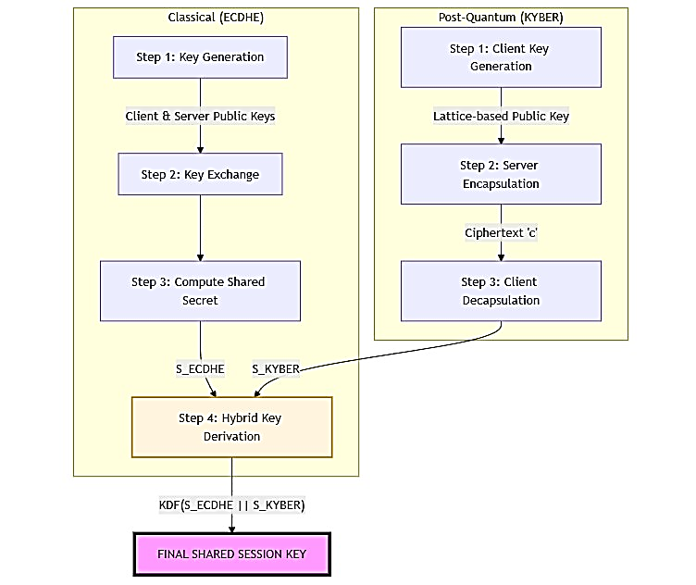  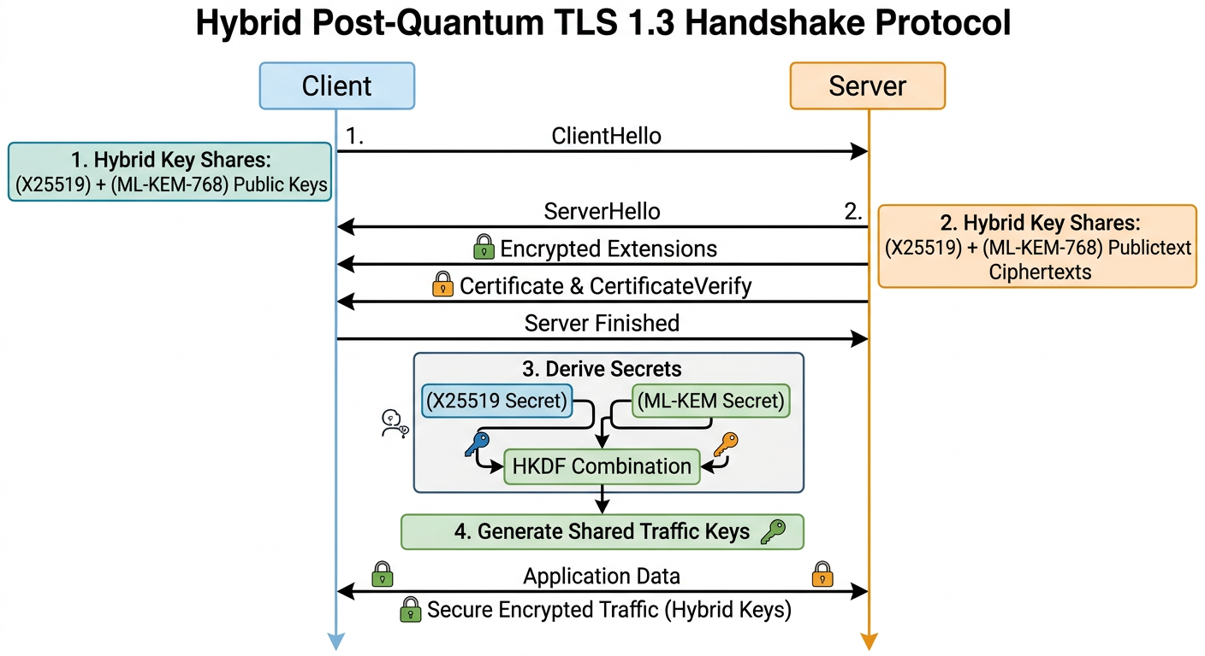
Support needed from Program office | I will require Doctor Soumya Maity as the mentor for my Capstone Project 1
References | - Mastercard, “Migration to post-quantum cryptography,” Mastercard Whitepaper, 2025.  Available: https://www.mastercard.com/content/dam/mccom/shared/news-and-trends/stories/2025/quantum-explainer-and-white-paper/Migration-to-post-quantum  - F5 Labs, “The state of post-quantum cryptography on the web,” F5 Labs Research Report, 2023.  Available: https://www.f5.com/labs/articles/the-state-of-pqc-on-the-web  - Utimaco and National Institute of Standards and Technology (NIST), “Post-quantum protocols for banking applications,” in Proc. Fourth Post-Quantum Cryptography Standardization Conf., 2022.  Available: https://csrc.nist.gov/csrc/media/Events/2022/fourth-pqc-standardization-conference/documents/papers/post-quantum-protocols-for-banking-applications.pdf  - International Journal of Scientific Research in Modern Technology (IJRSRMT), “Research article,” Int. J. Sci. Res. Mod. Technol., 2023.  Available: https://ijsrmt.com/index.php/ijsrmt/article/download/594/177/3694

